Buyer Declaration Letter
To,

ORIX Leasing & Financial Services India Limited
Andheri – Kurla Road, Andheri (E), Mumbai – 400 059.

Dear Sir,
Re: Sale of vehicle
We understand that ORIX Leasing & Financial Services India Limited has vehicle available for sale as per below mentioned details
Vehicle Make & Model | Tata Motors – Punch – Adventure Rhythm AT
Vehicle Registration No. | MH14LP2154
Kindly let us know the sale price expected by ORIX Leasing & Financial Services India Limited for the aforesaid vehicle, as I / we am / are interested in purchasing the same as per below detail.
Also, I hereby confirm to pay the applicable TCS as per below details:
- TCS Applicability: Sale value exceeds Rs. 10 lakh per vehicle/goods, TCS @ 1% will be applicable.
- As per section 139AA of the Income Tax act, 1961 every person who has been allotted PAN is required to link his PAN with his/her Aadhaar number on or before 30th June 2023. If the same is not linked TDS and TCS will be applicable at higher rates as per section 206AA and section 206CC respectively i.e. higher of either 2 times the rate prescribed in the Income Tax Act or Finance Act, or a flat 5%. If PAN is found to be inactive/inoperative TCS @ 20% will be applicable (For Individual User ONLY)
BILLING DETAIL & ADDRESS
 | BUYER ENTITY TYPE (Kindly select one) |  |  |  | Individual
BUYER BILLING ENTITY \ PERSON NAME* |  | Vishal Kumar
GST NUMBER** |  | NA
BUYER BILLING ADDRESS |  | C 607, Pristine Prolife Phase 3, Wakad
CITY* |  | Pune | POSTAL CODE* | 411057
STATE* |  | Maharashtra | CONTACT NUMBER* | 9589307943
EMAIL ID* |  | vishal152715@gmail.com
PAN No.* |  | AURPJ9761A
Is the Buyer PAN and Aadhaar linked? (Y/N) * |  | Yes
Note: Tax invoice will be issued as per the given buyer details

- I do hereby confirm that payment is being made by one of the following parties – User

Note: - Cash transactions towards Residual Value/Foreclosure payments are not acceptable.
Use same as above address for billing & Communication delivery purpose
COMMUNICATION ADDRESS
NAME: | Vishal Kumar
COMMUNICATION ADDRESS: | C 607, Pristine Prolife Phase 3, Wakad
CITY: | Pune | POSTAL CODE: | 411057
STATE: |  | CONTACT NUMBER:
EMAIL ID: | Vishal152715@gmail.com
Thanking You!
Yours faithfully,
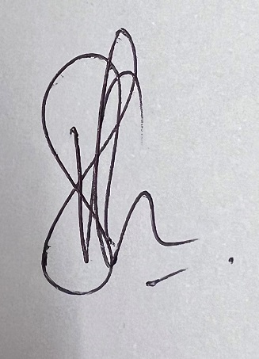
Vishal Kumar

